Case 5-Asia-China-Shang-Chariot Head-ca 2100 BCE

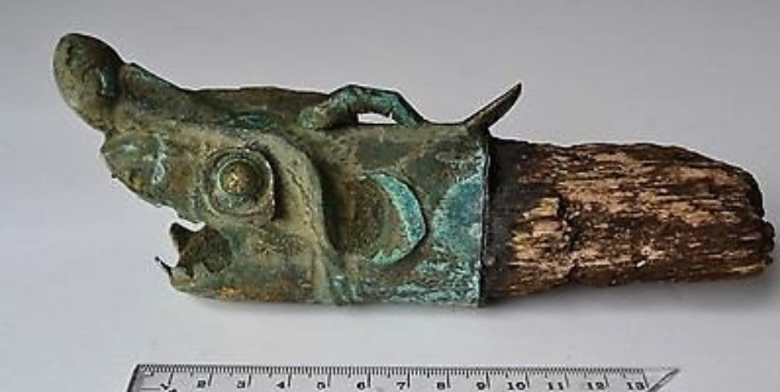

Fig. China-Shang-Chariot Head-ca 2100 BCE

Case no.: 5

Accession Number:

Formal Label: China-Shang-Chariot Head-ca 2100 BCE

**Display Description:** "Old Chinese Zhou Dynasty bronze chariot head. Beautiful patina and coloring. The wooden pole is brittle and fragile.."

This ancient Chinese chariot ([戰車](http://en.wiktionary.org/wiki/戰車) , p. *zhànchē* lit. "war vehicle") fitting on the yuán or draught pole possibly in the form of an alligator was probably from an entombment of a military commander who had used the alligator as an apotropaic emblem in his career as a charioteer.

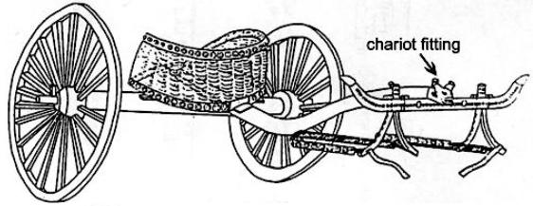

An ancient Chinese chariot ([戰車](http://en.wiktionary.org/wiki/戰車) , p. *zhànchē* lit. "war vehicle") with its chariot fitting of an alligator snout (length 16.6 cm.) as reconstructed on the 3 m. long *yuán* or draught pole was excavated from burial M20 at Anyang Xiaotun. Chariot reconstruction after Shih Chang-ju, Hsiao-t'un: Pei-tsu Mu-tsang, *Academia Sinica* 22(1950), p. 28

**LC Classification:**

Date or Time Horizon:

Geographical Area: Anyang Xiaotun

**Map:**

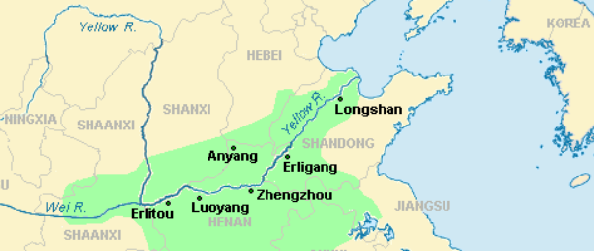

**GPS coordinates:**

Cultural Affiliation: Shang- ca 2100 BCE

Media: wood, bronze

Dimensions: L 22 cm

Weight:

Condition: original

Provenance: Inherited from a late relative who was stationed in PRC

**Discussion:**

The alligator as an apotropaic emblem on the battlefield suggests that its use was associated with its pugnacious ability to subdue its enemy by subduing and drowning it with great twirling force, and when this power was transferred to the field of battle it would make the alligator chariot a formidable weapon through the power it derived from its animal emblem. Archaeological evidence indicates that the chariot in ancient China was used as an attack and pursuit vehicle on the Central Plains from around 1200 BCE (Beckwith 2009: 43, Ebrey 2006: 14). However, the invention of the chariot was traditionally assigned by the first century CE philologist Xǔ Shèn to the legendary Xia Dynasty minister [Xi Zhong](http://en.wikipedia.org/wiki/Xi_Zhong) who successfully used it at the Battle of Gan (甘之战) *ca*. 2100 BCE (Xǔ Shèn, wg [Hsü Shen p] *Shuowen Jiezi,* [*Zhu Pian*](http://en.wikipedia.org/w/index.php?title=Zhu_Pian&action=edit&redlink=1) (玉篇), "Chariot Section" (车部)).

So in Chinese tradition the chariot had an ancient Shang Dynasty past that rendered it especially auspicious. And this auspiciousness was commuted to military commanders who used it in the late Shang period as a mobile staging device from which to direct troop movement. Therefore, the use of the alligator emblem on the chariot by a commander at Anyang, which was the center of power of the Shang Dynasty, would have invoked the high regard the commandery had for this apotropaic animal. This may be the reason why the use of the alligator motif is so rare in the archaeological record, because it may have had a restricted use to those in the high command. Located near the Zhangjiapo Village in Mawang Town of Chang'sn District in Xian City and on the west bank of the Fenghe River, the Western Zhou Chariot Burial Pit is a typical sacrificial tomb of slave society.

Archeologists have confirmed that the system of burying living people with the dead began in the Shang Dynasty (16th - 11th century BCE). At that time, many living slaves were buried with the dead, killed or committed suicide, since the slaves, the slave owner and the nobles all believed that the tombs they were populating were their residences in the spiritual world after their individual deaths.

The **Chinese alligator** (揚子鱷, (yáng zǐ è) *Alligator sinensis*) is one of only two known living species of *Alligator*, now native only to the lower reaches of the Yangtze River, along Yijiang and Taihu river-basin swamps and in the provinces of Jiangsu, Zhejiang, and Anhui. However, in the past its range was throughout most of This is a feature of only a few Crocodilia, an order of large reptiles which dates to 83.5 mya and is named for the so called "pebble-worm" (κροκόδειλος Greek) texture of its armor. This armor resembles the Chinese Shang bronze body textures of ritual containers. However, while the term crocodilian can be used as an adjective for these creatures, their true animal analogue is that of the Chinese alligator, which is not a crocodile.

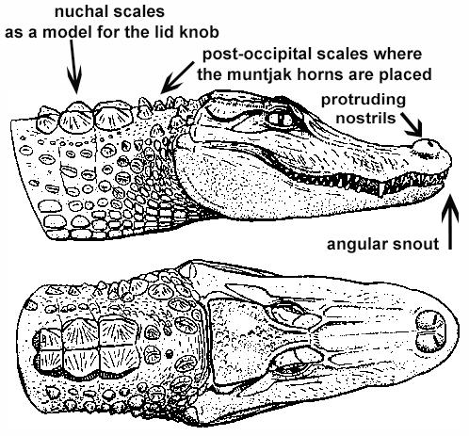

*Alligator sinensis* after Wermuth & Fuchs (1978)

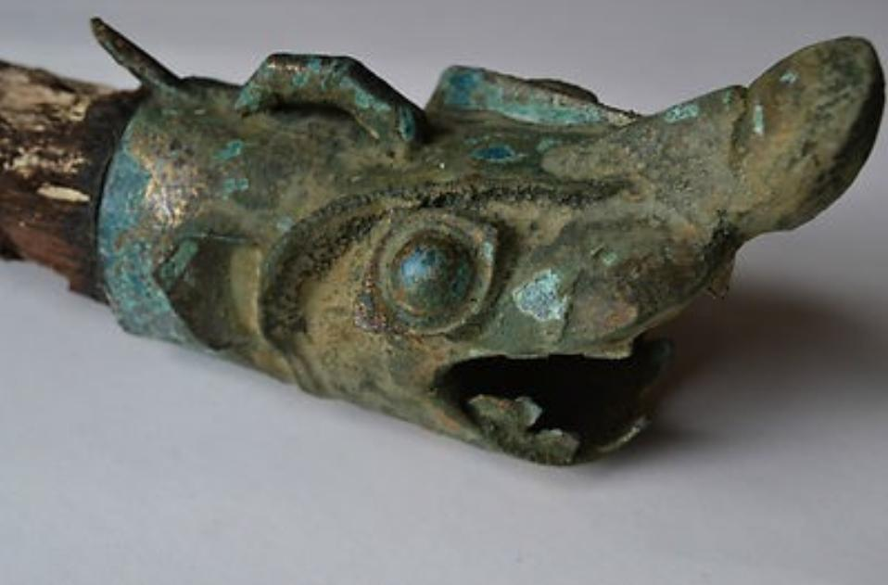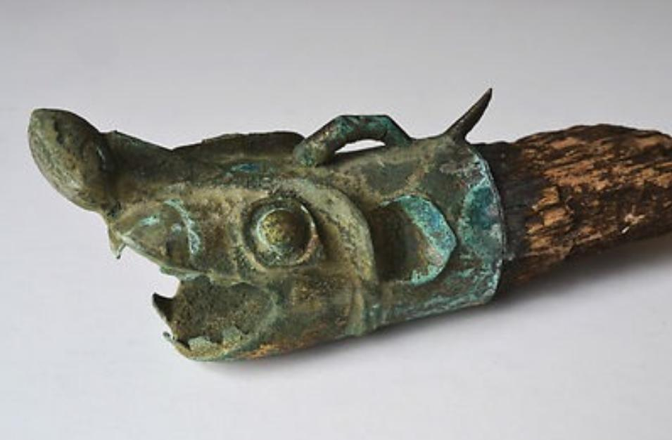

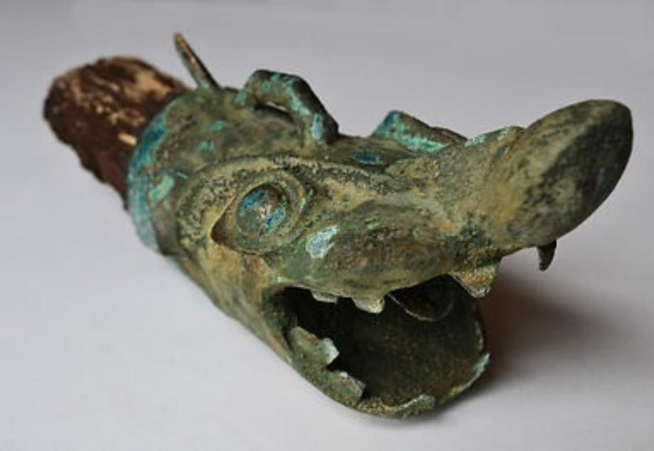

APPENDIX:

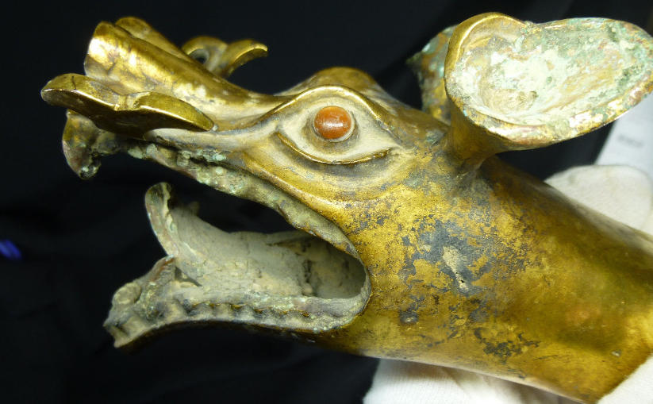

This ancient Chinese, Gilt-Bronze Dragon's Head Scepter dates to about the Eastern Zhou Dynasty or Warring States Period (770 BC—221 BC). It is in Museum Quality condition with only minor loss of the gilt obscured or missing from bronze oxidation. It retains an original and authentic patina of heavy, blue-green bronze oxidation and earthen deposits on both the interior and exterior from ancient ground contact over millennia in the damp soil.

Condition:

**--**

*“This ancient Chinese, Gilt-Bronze Dragon's Head Scepter dates to about the Eastern Zhou Dynasty or”*

Was:

~~US $165,000.00~~ 

You save:

**$66,000.00 (40% off)**

Price:

**US $99,000.00**

AP: 109 GBP

